Introduction

The commissioning of a new piece of artwork for Poole Crematorium has arisen, following the donation of the commission fee by a former Poole resident to the Borough of Poole’s Leisure Services Department.

The artwork should address issues raised and follow guidance set out in Borough of Poole’s established Public Art Strategy (details given in ‘Further Reading’ at the end of this brief).

SITE LOCATION
The address and location of the work will be Poole Crematorium, Gravel Hill, Poole, Dorset BH17 9BQ, which is situated to the north of Poole on the A349.

THE SITE
The identified site for the artwork within the grounds is a circular area of land of 50 meters squared (8m diameter) directly outside the Crematorium Visitors’ Reception (see images below).The site has a rural, secluded feel and is laid out across an undulating area of 10 acres, which is planted with an abundance of mature trees, shrubs and plants providing intimacy and space for reflection.

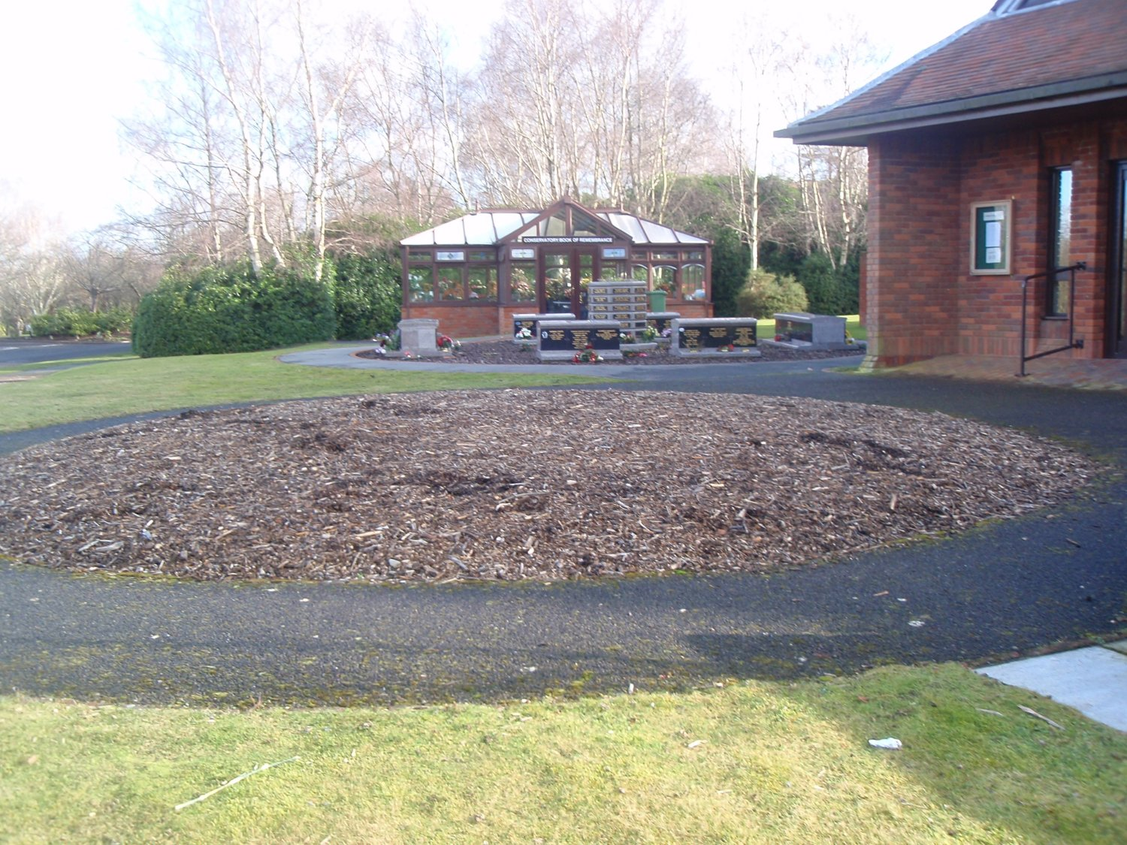
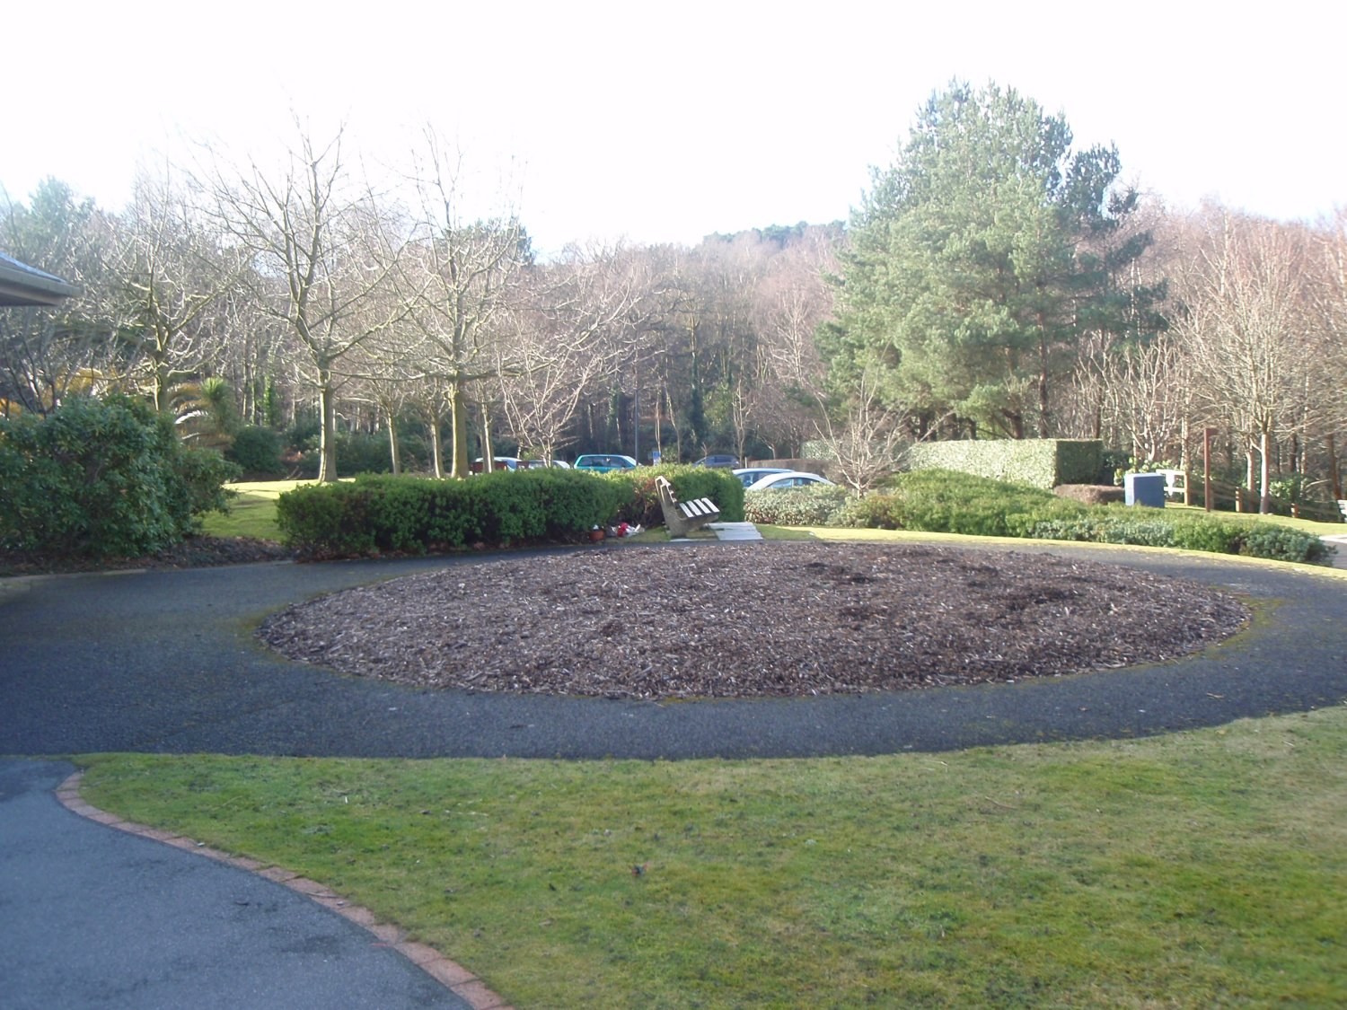

The Brief

Working with Crematorium staff, other Borough of Poole departments and an Elected Member the artist is required to produce a design for the arrangement, form, configuration, scale, materials, and finish to all of the built elements of the artwork. The completed artwork will need to be robust, durable and low maintenance.

An experienced artist is required to create a public artwork that enhances Crematorium visitors’ potential for quiet reflection and respects the serenity of the existing environment. The commission fee donor has requested that the artwork serve to commemorate, in particular, the deceased children of Poole.

This is an open brief, which it is hoped will attract a wide-ranging response from experienced artists working in the public realm. Power or water sources would be available if necessary and the completed, installed piece will be adopted by the Borough of Poole as part of their ongoing maintenance of the Crematorium grounds.

A maintenance schedule will be requested from the successful artist to accompany the artwork.

Submissions of interest from artists working in established partnerships with landscape architects and other design professionals are welcome.

Design Issues / site constraints

The artwork must:
- Have a minimal pollution impact in both the immediate and wider vicinity.
- Be designed, manufactured and installed using sustainable materials, processes and techniques wherever possible.
- Not unnecessarily distract or interfere with the operations of the nearby Visitors’ Centre or the functions of Crematorium staff.

PUBLIC CONSULTATION

Due to the sensitive nature of Crematorium business, consultation with visitors to the site is not considered appropriate.

Accessibility Design Issues

Issues of accessibility are central in decisions regarding the design and siting of the artwork and any interpretation (which should be adjacent to the artwork).

SELECTION CRITERIA

Artists will be short-listed on the basis of a demonstrable track record in the design, production and installation of permanent, high quality artwork in the external public realm.

APPOINTMENT PROCEDURE

Your initial submission, for expression of interest, should include the following:
- A letter stating:
Why you are interested in the project
How you would apply your existing knowledge, skills & experience.
- Your current CV
- 12 images of your work. Please send hard copies of these and an S.A.E if you would like these returned to you.
- The contact details of two referees for work completed within the last 3 years.

APPOINTMENT TIMETABLE

- Initial submissions deadline: Extended to Thursday 3rd Sept. 2009 at 5 p.m.
- Shortlisting to take place: Moved to Tuesday September 8th 2009
- Interviews to take place: Friday 18th September 2009

At interview, short-listed artists will be asked to give a presentation of their past work and an initial response to the site and project. We are not asking for proposals at this stage but a discussion about how past work relates to the opportunity at this site and thoughts on the approach that might be taken. Each short-listed artist will have 45-50 minutes for presentation and questions.

CONTRACT

The successful artist will be issued with a contract by the Borough of Poole Leisure Services Department, to which this brief will be appended. A draft of that contract will be available at interview. The artist will be employed by the Borough of Poole.

PROJECT RECRUITMENT AND MANAGEMENT PANEL

The panel will consist of:
Richard Nicholson Green Space Dev. Team Leader 01202 261347
Kevin Clark Deputy Superintendent Registrar 01202 261381
Nicky Whittenham Borough of Poole Public Art Officer 01202 262616
Cllr. Charles Meachin Borough of Poole Elected Member 01202 633018

OUTPUTS AND DESIGN AGREEMENT PROCESS / TIMETABLE:

- Successful artist appointed: T.B.C.
- Concept meeting (see below) T.B.C. on appointment of artist.
- Detailed design meeting (see below) T.B.C. on appointment of artist.
- Installation of artwork – date T.B.C.

Stage 1 – Concept
Further to their appointment the Artist will be asked to present their initial thoughts and work in progress to the project team at a concept presentation meeting.

This meeting will involve discussions of:
- concept
- design proposed
- technical implications
- maintenance issues

The meeting is for evaluation by the Project Panel. This process is intended to assess the initial practicality, workability and affordability of the proposals at an early stage in the process and to address and resolve any fundamental concerns.

Stage 2 – Detail Design
Following the Concept Design Stage meeting, the Artist will then be asked to produce detailed designs for the commission to a standard where accurate costing and a timetable for the finished scheme can be made. The detailed designs will include:

- sketches to illustrate the scheme, fully annotated with materials, fixing methods, and any other relevant information.
- a detailed written description, with a clear rationale behind the overall concept and explanation of each component.

Stage 3 – Project Completion
The artist will ensure installation of the completed artwork by Summer 2010

BUDGET AND FEES:

The maximum overall budget for the project is £20,000.00 inclusive of VAT, materials, fees and installation. No additional expenditure arising will be entertained. The artist’s fee for the Concept and Detailed Design Stages and installation is included within the overall budget. Most meetings will be in Poole.

FURTHER READING / INFORMATION:
The following documents can be downloaded at www.boroughofpoole.com :

The Borough of Poole’s Public Art Strategy
http://www.boroughofpoole.com/filemanager/147.pdf

Supplementary Planning Guidance document ‘Percent for Art’
http://www.boroughofpoole.com/filemanager/131.pdf

SUBMISSIONS:
Please ensure submissions (marked with reference: PC201), reach us by 5 p.m. on Thursday September 3rd 2009 and are addressed to:

Nicky Whittenham
BoP Public Art Officer
Arts Development Unit
Waterfront Museum
4 High Street
Poole
Dorset
BH15 1BW

Please contact Nicky on 01202 262616 or at artcommissions@poole.gov.uk or Richard Nicholson – Green Spaces Development Manager on 01202 261347 or at r.nicholson@poole.gov.uk if you have any other queries, concerns or requests for further information.

